Now that we have a stream created, we're going to write records to it.

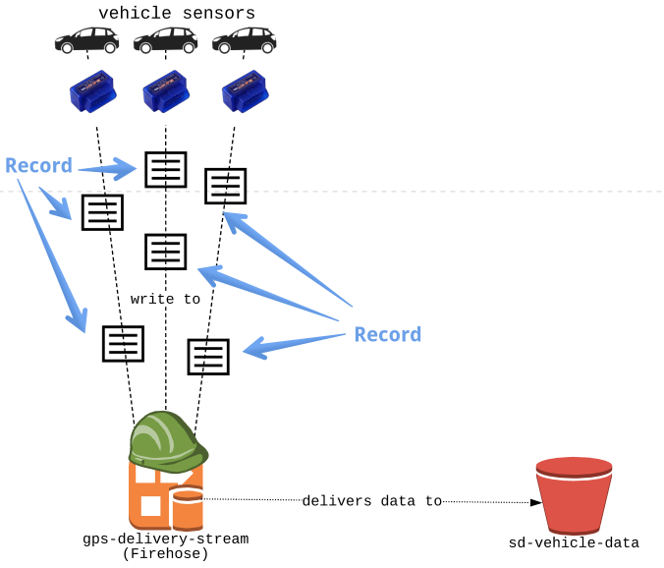

**File to edit**

You will be editing the OBD2_sensors.py file in the editor. These will simulate the sensors on the vehicle.

Since we don't have actual vehicle sensors (or vehicles) on hand, we'll be simulating telemetry data from a CSV file. It's a good way to test before going to production. The dataframe is available in the vehicle_data variable.

**Firehose Stream**:

In the last exercise you created the gps-delivery-stream Firehose stream. That's what we'll write to!

**Slides**

Don't forget - you can always click on the **slides** icon in the top right to see the slides - they'll be pretty helpful!

**Instructions**

**100XP**

* Create a payload string for every row of data that ends in a newline character.
* Send the payload to the gps-delivery-stream Firehose stream.
* Print the resulting written RecordId.

Code:

# OBD2_sensors.py: Write to Firehose stream. EDIT HERE.

import _setup, create_firehose

firehose, s3, records = _setup.ex_vars

for idx, row in records.iterrows():

# Create a payload string that ends with a newline

payload = ' '.join(str(value) for value in row)

payload = payload + "\n"

print("Sending payload: {}".format(payload))

# Send the payload string to Firehose stream

res = firehose.put_record(

DeliveryStreamName = 'gps-delivery-stream',

Record = {'Data': payload})

# Print the written RecordId

print("Wrote to RecordId: {}".format(res['RecordId']))